**DAILY ONLINE ACTIVITIES SUMMARY**

|  |  |  |  |  |  |  |  |  |
| --- | --- | --- | --- | --- | --- | --- | --- | --- |
| **Date:** | **31-05-2020** | | | | | **Name:** | **Javahar.S.Goutham** | |
| **Sem & Sec** | **7th b** | | | | | **USN:** | **4AL16CS132** | |
| **Online Test Summary** | | | | | | | | |
| **Subject** | | **No test** | | | | | | |
| **Max. Marks** | | **00** | | **Score** | | | **00** | |
| **Certification Course Summary** | | | | | | | | |
| **Course** | **Introduction to Ethical hacking** | | | | | | | |
| **Certificate Provider** | | | **Great Learning** | | **Duration** | | | **6 hrs** |
| **Coding Challenges**  **No programs** | | | | | | | | |
| **Status: Completed all Programs till date** | | | | | | | | |
| **Uploaded the report in Github** | | | | | **YES** | | | |
| **If yes Repository name** | | | | | <https://github.com/Goutham-dotcom/JavaharGoutham> | | | |

Online Test Details: (Attach the snapshot and briefly write the report for the same)

No test

Certification Course Details: (Attach the snapshot and briefly write the report for the same)

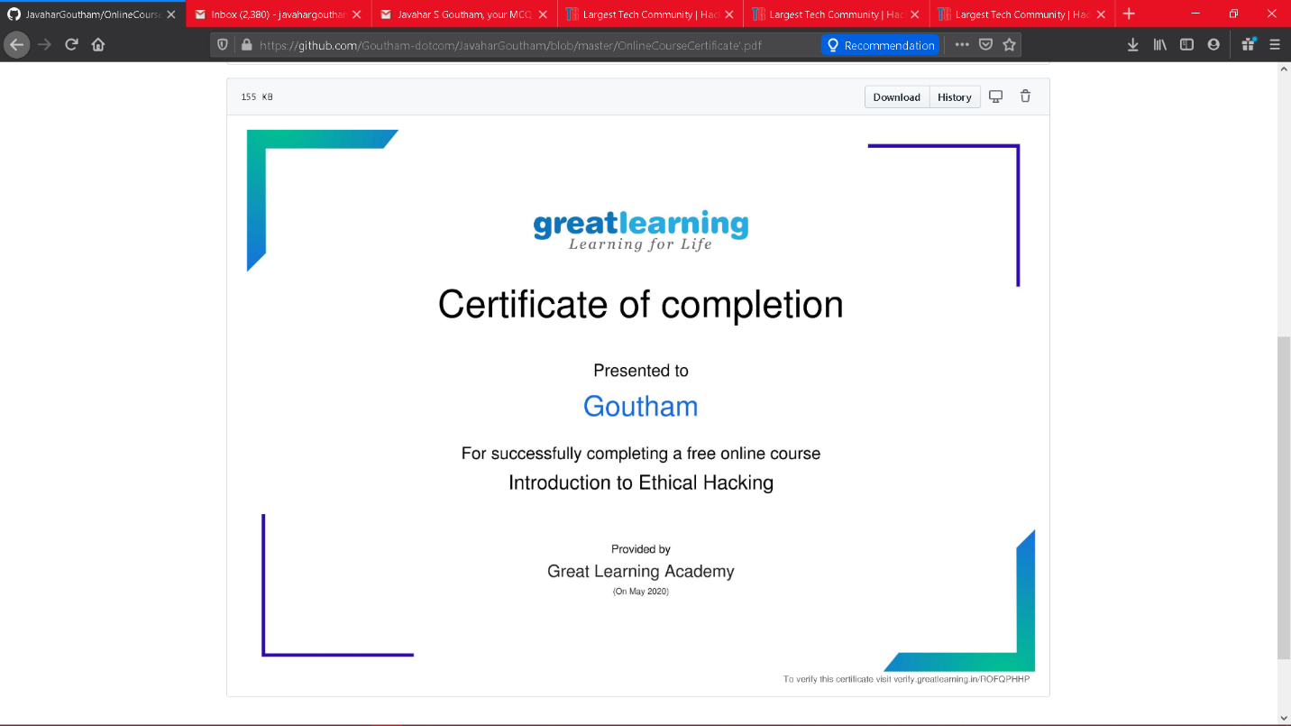

The above course is being taken up by me which is based on the Introduction to ethical hacking The details of the course and certificate provider is mentioned in the above form.

Coding Challenges Details: (Attach the snapshot and briefly write the report for the same

No programs where given

**Activity done for the day is solving quiz on Indainbix**

**Scored 17/20 in apti test 1**

**Scored 18/20 in apti test 2**